Lillie I. Myers
1870 – September 30, 1889

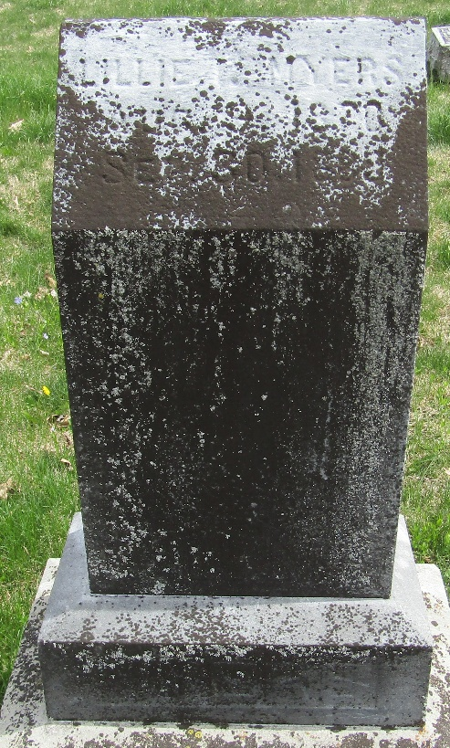

Lillie I Myers from tree Patrick Family Tree
Birth 1870 Bluffton, Wells, Indiana, USA
Residence 1880 Bluffton, Wells, Indiana, USA
Death 30 Sep 1889 Wells, Indiana, USA
Father Joseph Lee Myers (1838-1928)
Mother Lucretia Helen Shreve (Shrieves) (1846-1909)

