Joseph S. Myers
July 16, 1838 – August 21, 1928

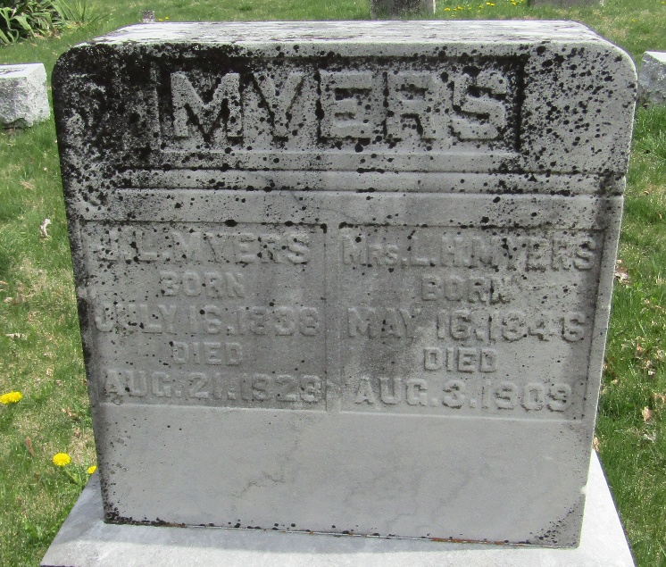

Joseph S Myers
Indiana, U.S., Death Certificates, 1899-2017
Name Joseph S Myers
Gender Male
Race White
Marital Status Widowed
Age 89
Birth Date 16 July 1838
Birth Place Ohio
Death Date 21 Aug 1928
Death Place Bluffton, Wells, Indiana, USA
Death Registration Date 1928
Father Jacob Myers
Mother Martha D DeHaven
Spouse Lucretia Shreve; deceased
Informant Jerry Myers; Bluffton, Indiana
Burial August 24, 1928; Murray Cemetery

