Joseph M. Myers
December 26, 1861 – June 9, 1881

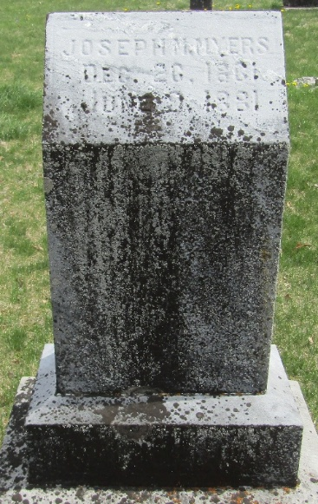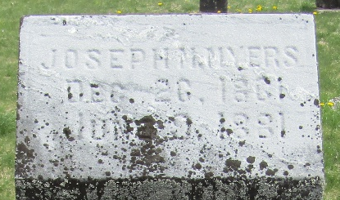

Joseph M. Myers from tree DeBolt/Shiley
Birth 26 Dec 1861 Fairview, Fulton, Illinois, USA
Residence 1880 Livingston, Missouri, USA
Death 9 Jun 1881 Bluffton, Wells, Indiana, USA
Father Simeon Myers (1837-1924)
Mother Mary Jane Bell (1836-1869)

