James E. Myers
April 13, 1850 – October 2, 1930

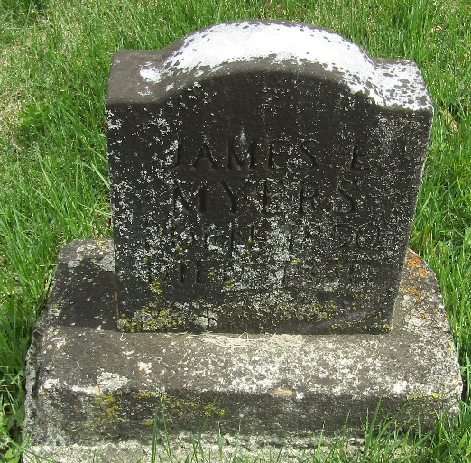

James E. Myers
Indiana, U.S., Death Certificates, 1899-2017
Name James E. Myers
Gender Male
Race White
Marital Status Single
Age 80 years, 5 months, 19 days
Birth Date 2 Oct 1930 [sic]
Birth Place Ohio
Death Date 2 Oct 1930
Death Place Harrison, Wells, Indiana, USA
Death Registration Date 1930
Father Jacob Myers
Mother Martha Dehaven
Informant Jerry Myers; Bluffton, Indiana
Burial October 4, 1930; Murray Cemetery

