Jacob Myers
March 27, 1813 – February 5, 1899

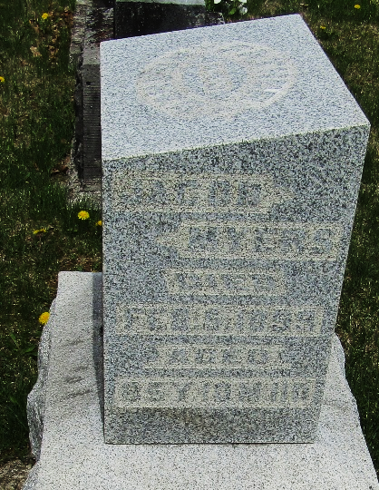

Jacob Myers, one of the pioneers of Wells County, died at his home one mile east of Murray, Sunday morning at eight o'clock. He had been sick only a few days, being seized last Thursday with a severe stroke of paralysis which left no hope of his recovery.
Mr. Myers was born in Portage County, Ohio, March 24, 1813. May 19, 1836 he was united in marriage to Miss Martha DeHaven. They made their home in Ohio for the following fifteen years, and in 1851 emigrated to Indiana. Mr. Myers settled on eighty acres of land in Lancaster Township, one mile east of Murray, where he has since lived, making him a resident of the county for nearly half a century. When Mr. Myers settled here, all was a wilderness and he lived to see it emerge into a populous and prosperous county.
There were born to Mr. and Mrs. Myers twelve children of whom nine survive their father. They are James, Orlin, and Joseph L. Myers of this county, Benjamin, William and Simeon living in Missouri, Mrs. William C. Black of Blackton, Ia., and Mrs. Lew Staver and Mrs. Charles Eversole of this county. None of the children living at a distance were able to arrive home in time for the funeral. Mr. Myers was in his eighty-sixth year, and if he had lived until May, would have celebrated his 63rd wedding anniversary. His wife survives him.
Funeral services were conducted at Murray Monday afternoon at 2 o'clock by Rev. Bailey, with interment at the same place.
Bluffton Chronicle, Wells County, Indiana
Wednesday, February 8, 1899
**
Jacob Myers from tree DeBolt/Shiley
Birth 27 Mar 1813 Streetsboro, Portage, Ohio, USA
Marriage 19 May 1836 Portage, Wood, Ohio, USA
Residence 1880 Wells, Indiana, USA
Death 5 Feb 1899 Wells, Indiana, USA
Father Stephen Myers (1759-1864)
Mother Catherine Graham (1761-1850)
Spouse Martha DeHaven (1815-1906)

