Elizabeth (Aungst) Myers
July 23, 1820 – March 21, 1891

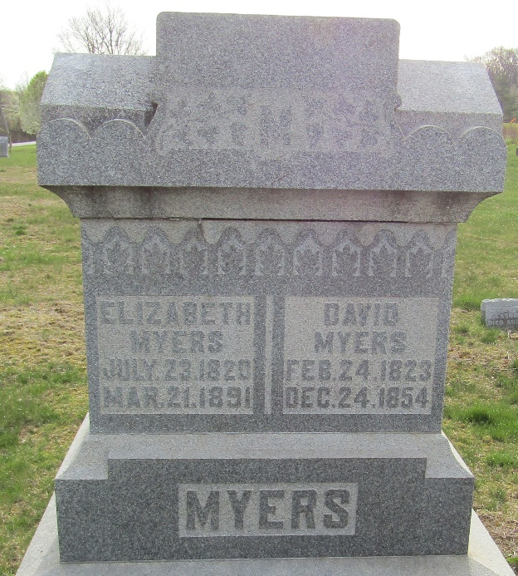

Elizabeth AUNGST from tree Porter, Coleman, Smith, Keller, Cunkle
Birth 23 Jul 1820 Ohio, USA
Marriage 1860 Indiana, USA
Residence 1880 Wells, Indiana, USA
Death 21 Mar 1891 Wells, Indiana, USA
Father George W AUNGST (1783-1841)
Mother Elizabeth ZIMMERMAN (1788-1862)
Spouse David MYERS (1823-1854)

