Della Myers
May 20, 1848 – July 23, 1850

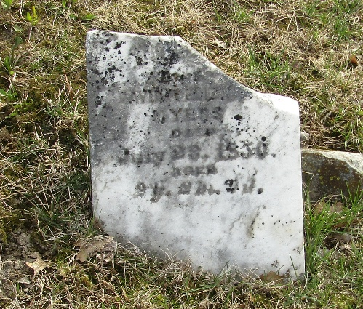

Della Myers from tree michael_gingerich_for_susan
Birth 20 May 1848 Wells, Indiana, USA
Death 23 Jul 1850 Wells, Indiana, USA
Father David Myers (1823-1854)
Mother Elizabeth Aungst (1820-1891)

