David Myers
February 24, 1823 – December 24, 1854

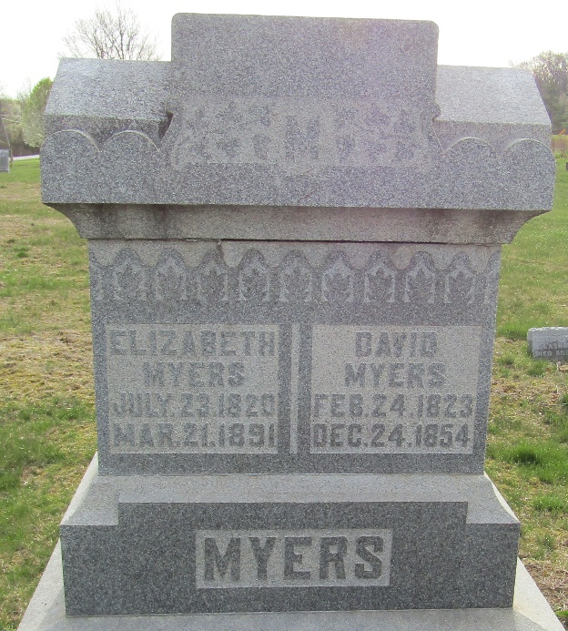

David Myers from tree Grist/Sleighter Tree
Birth 24 Feb 1823 Woodbury, Bedford, Pennsylvania, USA
Marriage 26 Aug 1841 Jefferson, Richland, Ohio, USA
Residence 1850 Wells, Indiana, USA
Death 24 Dec 1854 Wells, Indiana, USA
Father Christian Mayer/Myers (1779-1860)
Mother Barbara Rachel Gingerich (1787-1833)
Spouse Elizabeth Aungst (1820-1891)

