Christina (Swartz) Myers
August 17, 1859 – October 31, 1929

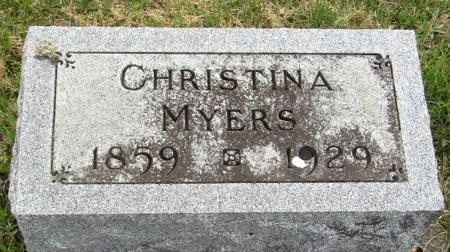

Mrs. Myers Dies Thursday Evening
Death Occurs at County Hospital
Resident In County 42 Years
Mrs. Christena Swartz Myers, widow of Orlin Myers, died Thursday evening at 7 o'clock at the county hospital. Mrs. Myers was born in Montgomery County, Ohio, a daughter of Mr. and Mrs. Jacob Swartz, both of whom were born in Germany. Her marriage to Mr. Myers, who is deceased, took place in December 1895.
A stepson survives. He is Harley Myers, of Markle. John Swartz and Mrs. Elizabeth Smith, of Fort Wayne, are a brother and sister.
Mrs. Myers had been a resident of Wells County for forty-two years.
The funeral will be held at the Murray Church at 2 o’clock on Sunday afternoon with Rev. Tarr in charge. Burial will be in the Murray Cemetery.
Bluffton Evening News, Wells County, Indiana
Friday, November 1, 1929
**
Indiana, U.S., Death Certificates, 1899-2017
Name Christena Myers [Chreslena Swartz]
Maiden Name Swartz
Gender Female; Race White
Marital Status Widow
Age 73
Birth Date 17 Aug 1856; Birth Place Montgomery County, Ohio
Death Date 31 Oct 1929; Death Place Bluffton, Wells, Indiana, USA
Death Registration Date 1929
Father Jacob Swartz
Mother Unknown
Spouse Orlin Myers
Informant Mrs. Grace Wasson; Bluffton, Indiana
Burial November 3, 1929; Murray Cemetery

