Catherine (Dunham) Myers
September 20, 1880 – April 26, 1944

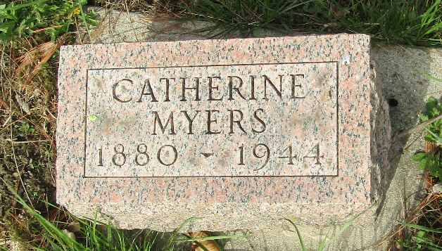

Catherine Myers
Indiana, U.S., Death Certificates, 1899-2017
Name Catherine Myers
[Catherine (Durham)]
Gender Female
Race White
Marital Status Married
Age 63
Birth Date 20 Sep 1880
Birth Place Morgantown, West Virginia
Death Date 26 Apr 1944
Death Place Bluffton, Wells, Indiana, USA
Death Registration Date 1944
Father William Durham
Mother Unknown
Spouse W O Myers; age 66
Informant W. O. Myers; Craigville, Indiana
Burial April 28, 1944; Murray Cemetery; Murray, Indiana
**
Catherine Dunham from tree T & C Link Family Tree
Birth 20 Sep 1880 Morgantown, Monongalia, West Virginia, USA
Marriage 20 Sep 1938 Wells, Indiana, USA
Residence Craigville, Wells, Indiana, USA
Death 26 Apr 1944 Bluffton, Wells, Indiana, USA
Father William Denham
Mother Alice Beans
Spouse James Leeper (1852-1934)
Spouse William Obediah Myers (1878-1952)

