Caroline V. (Robinson) Myers
December 2, 1855 – April 4, 1895

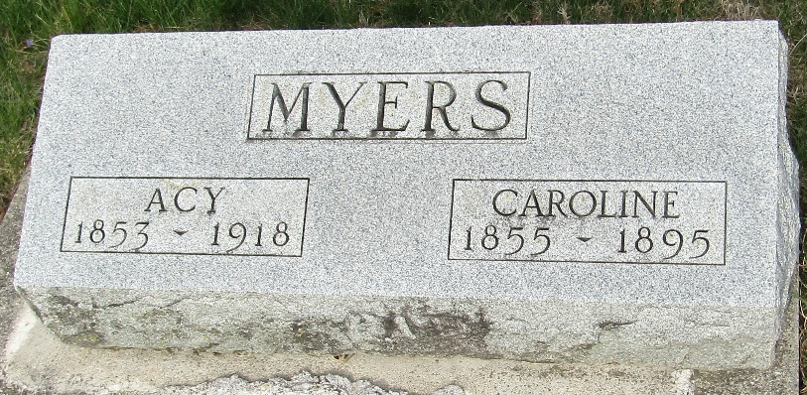

Caroline V. Myers from tree Myers Family Tree
Birth 2 Dec 1855 Jefferson, Richland, Ohio, USA
Marriage 17 Dec 1874 Richland, Ohio, USA
Residence 1880 Jefferson, Richland, Ohio, USA
Death 4 Apr 1895 Wells, Indiana, USA
Father Alexander Robinson (1806-1882)
Mother Margaret Detweiler (1818-1881)
Spouse Asa John "Acy" Myers (1853-1918)

