Acy J. Myers
February 4, 1853 – October 17, 1918

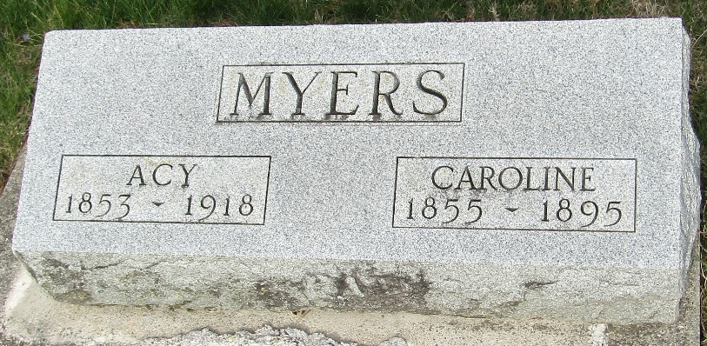

Acy Myers
Indiana, U.S., Death Certificates, 1899-2017
Name Acy Myers
Gender Male
Race White
Marital Status Widowed
Age 65
Birth Date 4 Feb 1853
Birth Place Indiana
Death Date 17 Oct 1918
Death Place Lancaster, Wells, Indiana, USA
Death Registration Date 1918
Father David Myers
Mother Unknown
Informant Julius Lindeman; Tocsin, Indiana
Burial October 20, 1918; Murray Cemetery

