Muriel Marguerite Mullen
August 6, 1913 – December 9, 1913

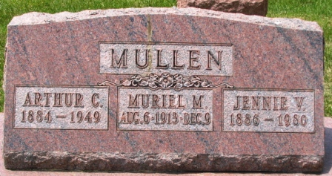
Photo by Barbara Baker Anderson

Muriel Marguerite Mullen
Indiana, U.S., Death Certificates, 1899-2017
Name Muriel Marguerite Mullen
Gender Female
Race White
Age 4/12
Birth Date 6 Aug 1913
Birth Place Poe, Indiana
Death Date 9 Dec 1913
Death Place Poe, Allen, Indiana, USA
Death Registration Date 1913
Father Arthur Mullen
Mother Jennie Boyce
Informant Jennie Mullen; Poe, Indiana
Burial Date & place not stated

