Jennie V. (O’Brien) Mullen
1886 - 1980

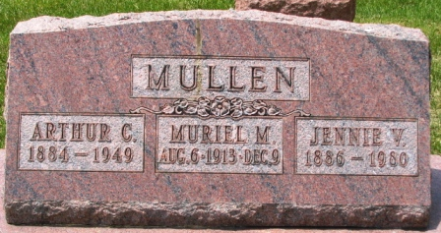
Photo by Barbara Baker Anderson

No further information found at this time

