George Nelson Mullen
1889 - 1907

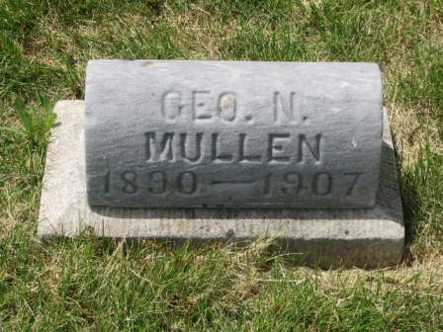
Photo by Barbara Baker Anderson

George Nelson Mullen from tree Cindy’s Tree
Birth Nov 1889 Indiana, USA
Residence 1900 Allen, Indiana, USA
Death 1907
Father Thomas Erastus Mullen (1850-1932)
Mother Eveline "Evyline" Nicholson (1862-1916)

