Arthur C. Mullen
October 22, 1884 – December 13, 1949

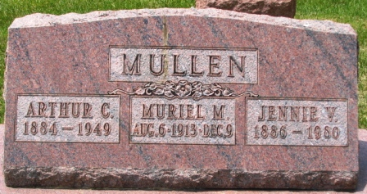
Photo by Barbara Baker Anderson

Arthur C Mullen from tree Bender Family Tree
Birth 22 Oct 1884 Indiana, USA
Residence 1 Apr 1940 Fort Wayne, Allen, Indiana, USA
Death 13 Dec 1949 Miami, Indiana, USA
Father Thomas Mullen (1849-1932)
Mother Eveline Nicholson (1864-1916)
Spouse Jennie Obrien (1887-1960)

