William D. Mills
1851 - March 30, 1859

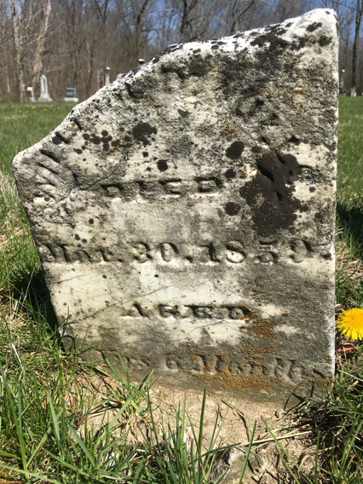
Photo by Barbara Baker Anderson

No further information found at this time

