Samuel Mills
March 3, 1826 – June 29, 1907

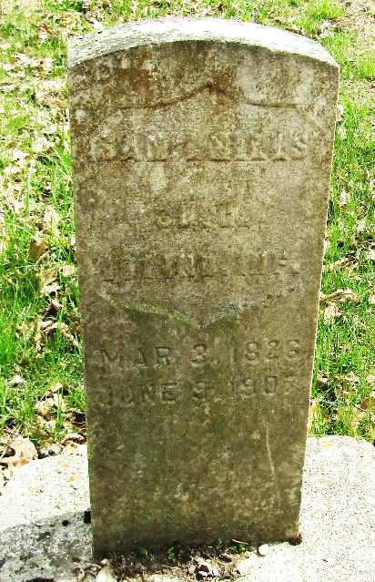

Samuel Mills was born in Licking County, Ohio, March 3, 1826, and departed this life June 29, 1907, aged 81 years, three months and 26 days. He was the son of Abraham and Margaret Pease Mills, natives of Pennsylvania, who emigrated from Ohio to Wells County, Indiana, in 1840, settling on the land known as the Wible farm.
Samuel, at the age of 23 years, purchased a 160-acre tract, eighty acres of which he lived on until his demise. He early learned privation and hardship common, and in early settlers of this country and in clearing his farm he showed great strength and endurance, yielding an axe with great power, and but few, if any, equaled him in clearing his land. No one did more than he toward wiping out the wilderness and converting the land into beautiful farms. Through industry, coupled with economy, in no sense approaching parsimony, enabled him to become the owner of a fine and well improved farm. He was an excellent farmer, taking great pride in his work and was always in the lead; planting when others were plowing, husking when others were cutting, but because of old age and the inroads of disease, he began to fee! the ravages of time and was compelled to lay down the tools of the farm and wait the inevitable.
Mr. Mills was twice married, in May 23, 1849, he chose for his companion Miss Magdaline Bender. To this union were born five children. S. C. of Adams County, Sarah Ellen Kleinknight of Kingland, Sylvester of Wells County; L. C. of Adams County, and Mary Jane Sowards of Tocsin. In the spring of 1879, he was again married to Margaret Phebie Gibbs. To this union were born two children, Henry and Ethel, residing in Wells County.
We can say that a more, kind-hearted, charitable and accommodating neighbor never lived than Samuel Mills. He was ever ready to aid a neighbor in distress, and his aid came from the heart. He answered his country's call for volunteers during the great rebellion, enlisting in August 1862, with Mr. James Wasir Company G. 101st Indiana Infantry. He served his country with credit and was honorably discharged after suffering a long and severe spell of sickness.
He leaves a wife, seven children, twenty-five grandchildren, and eleven great-grandchildren to mourn his departure. He bore his suffering with great fortitude and often remarked that he was at peace with his God and ready to go.
The funeral services were held at the Emmanual M. E. Church last Sunday at 2 p m., conducted by the Rev. A. J. Duryee, of Uniondale, interment in Murray Cemetery.
Decatur Daily Democrat, Adams County, Indiana
Monday, July 8, 1907
**
Indiana, U.S., Death Certificates, 1899-2017
Name Samuel Mills
Gender Male; Race White
Marital Status Married
Age 81
Birth Date 3 Mar 1826; Birth Place Ohio
Death Date 29 Jun 1907; Death Place Lancaster, Wells, Indiana, USA
Father Abraham Mills
Mother Margaret Pease
Spouse Phoeba
Informant Phoeba Mills; Craigville, Indiana
Burial June 30, 1907; Murray Cemetery

