Luna R. Mills
July 2, 1859 – November 14, 1881

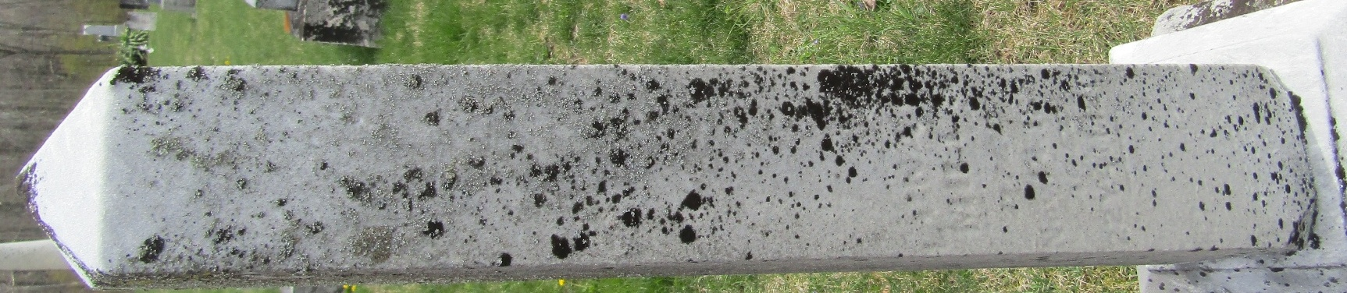

No further information found at this time

