John Mills
April 14, 1819 – November 17, 1855

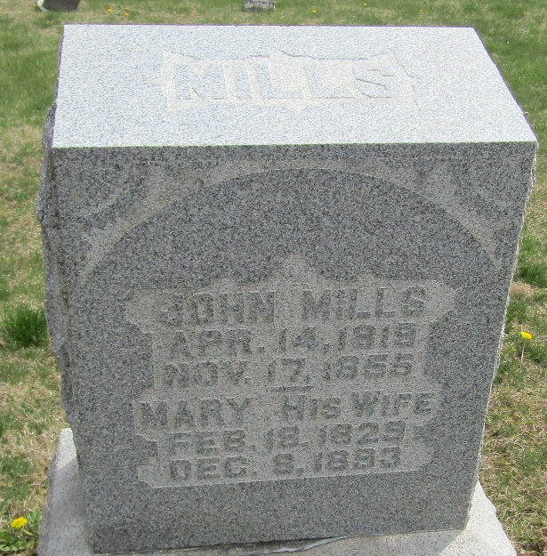

John Mills from tree Hall and Shady Family Tree
Birth 14 Apr 1819 Ohio, USA
Marriage 12 Aug 1847 Wells, Indiana, USA
Death 17 Nov 1855
Father Abraham Mills (1792-1855)
Mother Margaret (Peggy) Pease Mills (1798-1888)
Spouse Mary Nash Mills (1829-1893)

