Henry M. Mills
1849 – December 29, 1869

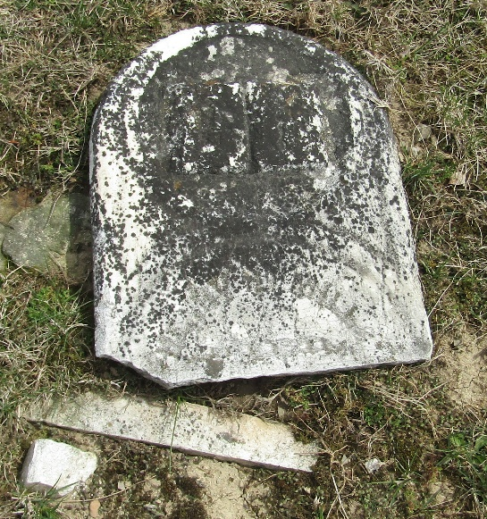

Henry M Mills from tree Millington Family Tree
Birth 1849 Wells, Indiana, USA
Residence 1860 Bluffton, Wells, Indiana, USA
Death 29 Dec 1869 Wells, Indiana, USA
Father John Mills (1819-1855)
Mother Mary Nash (1829-1893)

