Elijah A. Mills
1834 – October 2, 1855

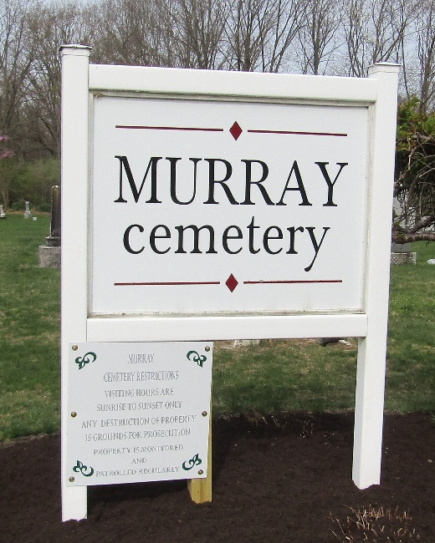

Elijah A. Mills from tree Hall and Shady Family Tree
Birth 1834 Ohio, USA
Residence 1850 Wells, Indiana, USA
Death 2 Oct 1855 Indiana, USA
Father Abraham Mills (1792-1855)
Mother Margaret (Peggy) Pease Mills (1798-1888)

