Dilda Alice (Stowe) Mills
December 1, 1856 – March 10, 1879

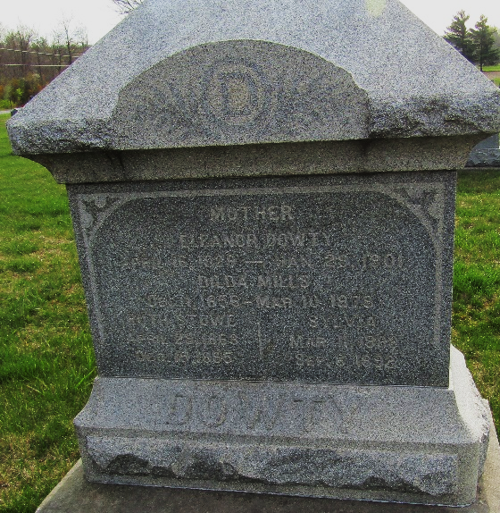

Dilda Alice Stowe in Jean Family Tree
Spouse Lewis Benjamin MILLS
Father Charles W. Stowe
Mother Eleanor Ellen Sowards
Children Charles Clement
Birth 1 Dec 1856 Ohio, USA
Death 10 Mar 1879 Wells, Indiana, USA
Residence 1870 Wells, Indiana, USA

