Pearl (Deeter) Millington
August 6, 1878 – November 16, 1962

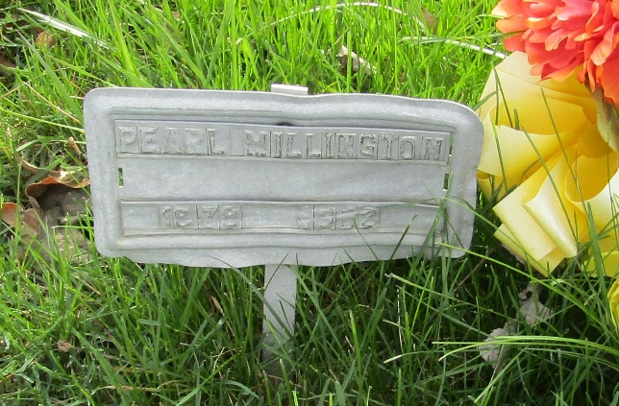

Pearl Millington
Indiana, U.S., Death Certificates, 1899-2017
Name Pearl Millington
[Pearl Deeter]
Gender Female
Race White
Marital Status Married
Age 84
Birth Date 6 Aug 1878
Birth Place Muncie, Indiana
Death Date 16 Nov 1962
Death Place Bluffton, Wells, Indiana, USA
Death Registration Date 1962
Father Joseph Deeter
Mother Jane Shipley
Informant Mrs. Leona Wolf; daughter; Bluffton, Indiana
Burial November 18, 1962; Murray Cemetery; Bluffton, Indiana

