Paul O. Millington
May 17, 1895 – June 7, 1895

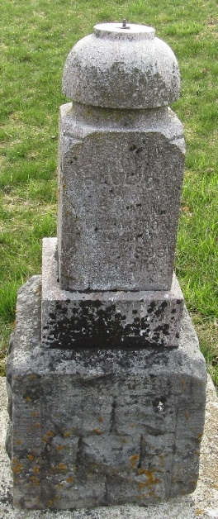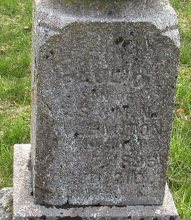

Paul Millington
Indiana, U.S., WPA Death Index, 1882-1920
Name Paul Millington
Date Jun 07, 1895
Location Wells County
Age 2 Dy
Gender Male
Race White
Source location County Health Office, Bluffton
Source notes The source of this record is the book H-14 on page 100 within the series produced by the Indiana Works Progress Administration.
**
Paul O. Millington from tree Aikins/Hetrick-Robertson/Zipse Family Tree
Birth 17 May 1895 Wells, Indiana, USA
Death 7 Jun 1895 Wells, Indiana, USA
Father Alvin Sanford Millington (1862-1928)
Mother Nancy Myrtle Goff (1877-1954)

