Luther G. Millington
October 10, 1889 – October 26, 1968

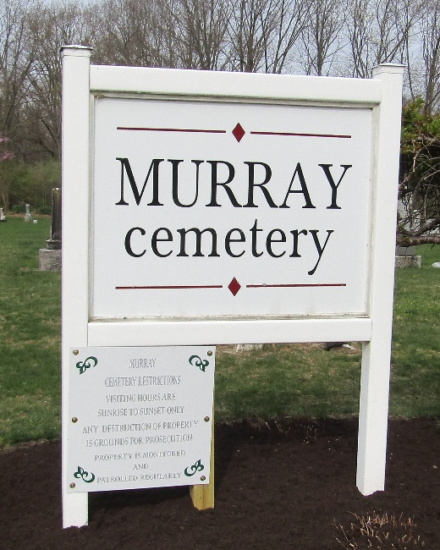

Luther G. Millington, 79, of 116 South Union Street, died Saturday at Wells County Hospital. A native of Allen County, he had lived in Wells County most of his lifetime.
He was born October 10, 1889, a son of Albert T. and Jane Dishong Millington; his first marriage was to Justina Smelker and his second to Pearl Deeter Brown, both of whom are deceased. One brother, Philemon Millington of Bluffton, survives.
Services will be conducted today at the Thoma Funeral Home; burial in the Murray Cemetery.

Wells County, Indiana Obituaries
October 26, 1968

**
Indiana, U.S., Death Certificates, 1899-2017
Name Luther G Millington
Gender Male
Race White
Marital Status Widowed
Age 79
Birth Date 10 Oct 1889
Birth Place Indiana
Death Date 26 Oct 1968
Death Place Bluffton, Wells, Indiana, USA
Death Registration Date 1968
Father Albert T Millington
Mother Jane Dishong
Informant Philemon Millington; Bluffton, Indiana
Burial October 28, 1968; Murray Cemetery; Murray, Indiana

