Dartha A. Millington
December 1, 1914 – December 10, 1914

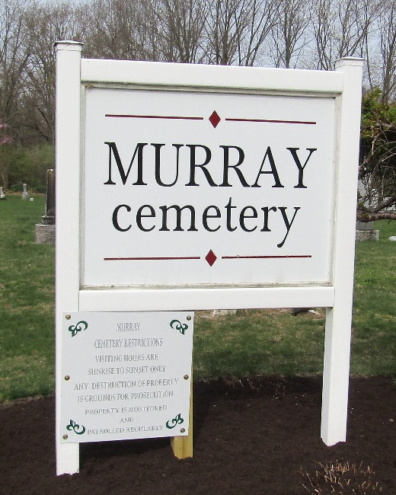

Dartha A Mellington
Indiana, U.S., Death Certificates, 1899-2017
Name Dortha A Millington
Gender Female
Race White
Marital Status Single
Age 10 days
Birth Date 1 Dec 1914
Birth Place Bluffton, Indiana
Death Date 10 Dec 1914
Death Place Bluffton, Wells, Indiana, USA
Death Registration Date 1910-1919
Father Ira Millington
Mother Lillian Ireland
Informant Ira Millington; Bluffton, Indiana
Burial December 11, 1914; Murray Cemetery

