Cora Bell Millington
July 25, 1872 – September 22, 1889

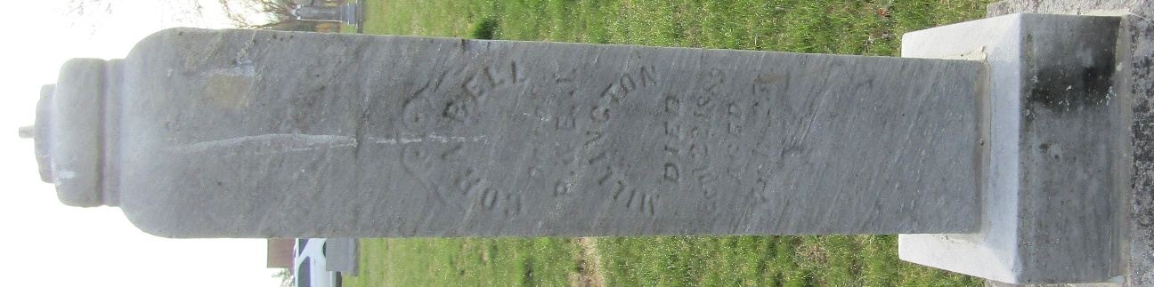

Cora Bell Millington from tree Millington Family Tree
Birth 25 Jul 1872 Indiana, USA
Residence 1880 Wells, Indiana, USA
Death 22 Sep 1889 Indiana, USA
Father Philemon Millington (1820-1894)
Mother Emma Jane Worden (1836-1911)

