Cora Millington
1896 - July 17, 1896

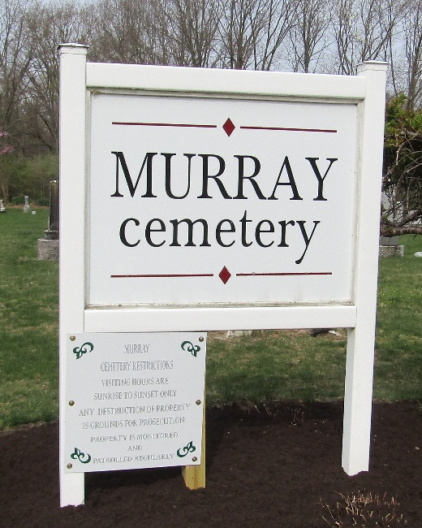

Cora Millington
Indiana, U.S., WPA Death Index, 1882-1920
Name Cora Millington
Date Jul 17, 1896
Location Wells County
Age 3 Mon
Gender Female
Race White
Source location County Health Office, Bluffton
Source notes The source of this record is the book H-14 on page 126 within the series produced by the Indiana Works Progress Administration.

