Alvin S. Millington
March 21, 1862 – May 20, 1928

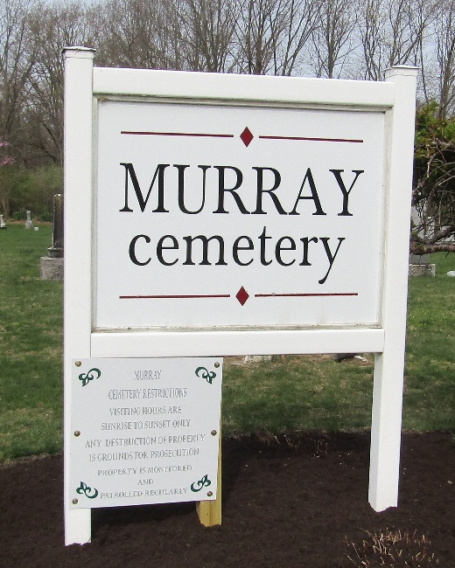

Alvin S. Millington
Indiana, U.S., Death Certificates, 1899-2017
Name Alvin S. Millington
Gender Male
Race White
Marital Status Widowed
Age 66
Birth Date 21 Mar 1862
Birth Place Ohio
Death Date 20 May 1928
Death Place Clay City, Kosciusko, Indiana, USA
Death Registration Date 1928
Father Thielmon Millington
Mother Emma Werdon
Spouse Nancy; deceased
Informant Clyde Millington; Claypool, Indiana
Burial May 22, 1928; Bluffton, Indiana

