Allen H. Millington
August 12, 1911 – May 9, 1912

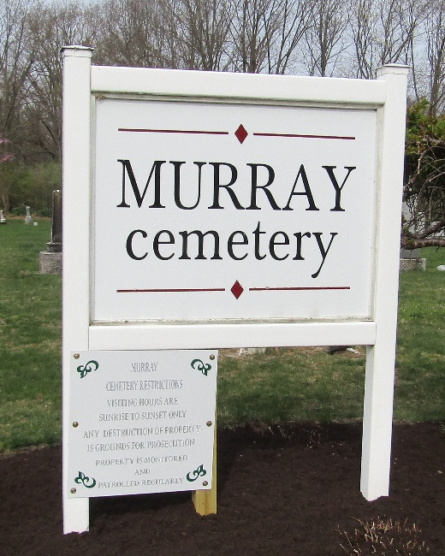

Allen H Millington
Indiana, U.S., Death Certificates, 1899-2017
Name Allen H Millington
Gender Male
Race White
Marital Status Single
Age 8 months, 27 days
Birth Date 12 Aug 1911
Birth Place Michigan
Death Date 9 May 1912
Death Place Bluffton, Wells, Indiana, USA
Death Registration Date 1912
Father Oscar Millington
Mother Mary Gilbert
Informant Family; Bluffton, Indiana
Burial May 10, 1912; Murray Cemetery

