Wilmetta Miller
April 21, 1902 – May 20, 1902

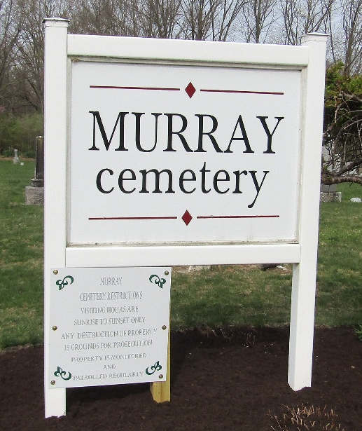

Wilmetta Miller
Indiana, U.S., Death Certificates, 1899-2017
Name Wilmetta Miller
Gender Female
Race White
Marital Status Single
Age 29 days
Birth Date 21 Apr 1902
Birth Place Indiana
Death Date 20 May 1902
Death Place Lancaster, Wells, Indiana, USA
Death Registration Date 1902
Father Elzie Miller
Mother Emma Miller
Informant Family; Bluffton, Indiana
Burial May 21, 1902; Murray Cemetery

