Susan (Edington) Miller
January 27, 1842 – July 18, 1916

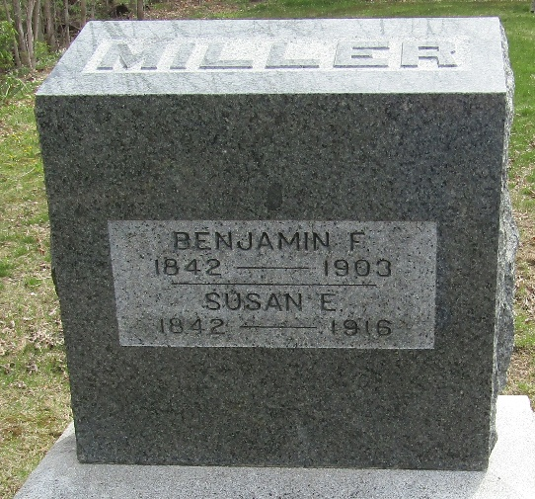

Susan Miller
Indiana, U.S., Death Certificates, 1899-2017
Name Susan Miller
[Susan Edington]
Gender Female
Race White
Marital Status Widow
Age 74
Birth Date 27 Jan 1842
Birth Place Darke Co, Ohio
Death Date 18 Jul 1916
Death Place Bluffton, Wells, Indiana, USA
Death Registration Date 1916
Father John Edington
Mother Elizabeth Noggle
Spouse Benj. F Miller
Informant V. C. Miller; Terre Haute, Indiana
Burial July 21, 1916; Murray Cemetery

