Simon Miller
December 8, 1832 – September 22, 1902

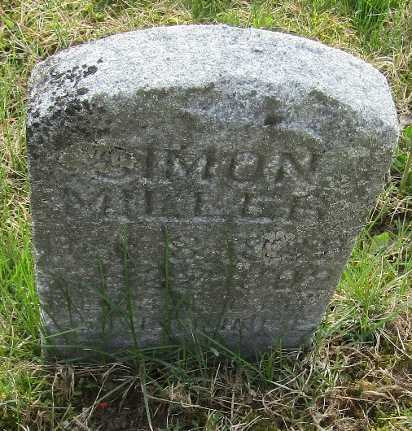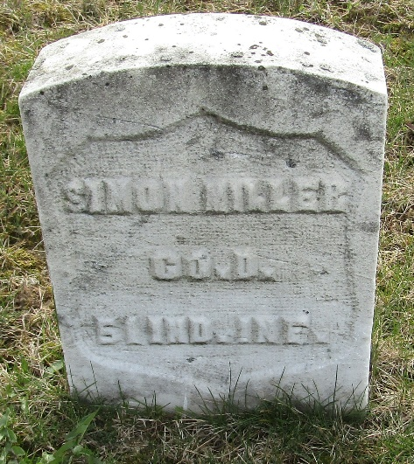

Simon Miller
Indiana, U.S., Death Certificates, 1899-2017
Name Simon Miller
Gender Male
Race White
Marital Status Widowed
Age 70
Birth Date 1832
Birth Place Ohio
Death Date 22 Sep 1902
Death Place Markle, Huntington, Indiana, USA
Death Registration Date 1902
Father Henry Miller
Mother Unknown
Spouse Mary Jane Whitney
Informant Mart Miller; Markle, Indiana
Burial September ??, 1902; Cemetery not stated
**
U.S., Civil War Soldier Records and Profiles, 1861-1865
Name Simon Miller
Enlistment Date 12 Jul 1863
Enlistment Rank Private
Muster Date 12 Jul 1863
Muster Place Indiana
Muster Company D
Muster Regiment 51st Infantry
Muster Information Drafted
Muster Out Date 21 Jul 1865
Side of War Union
Survived War? Yes
Residence Place Bluffton, Indiana
Title Report of the Adjutant General of the State of Indiana

**
Simon Miller from tree CLAPIER2
Birth 8 Dec 1832 Union, Indiana, USA
Marriage 23 Mar 1854 Wells, Indiana, USA
Residence 1880 Bartholomew, Indiana, USA
Death 22 Sep 1902 Markle, Wells, Indiana, USA
Father Henry Miller (1802-1882)
Mother Catharine "Caty" Seek (1801-1877)
Spouse Mary Jane Aker (Born 1833)

