Sarah E. (Maddux) Miller
July 18, 1851 – November 4, 1888

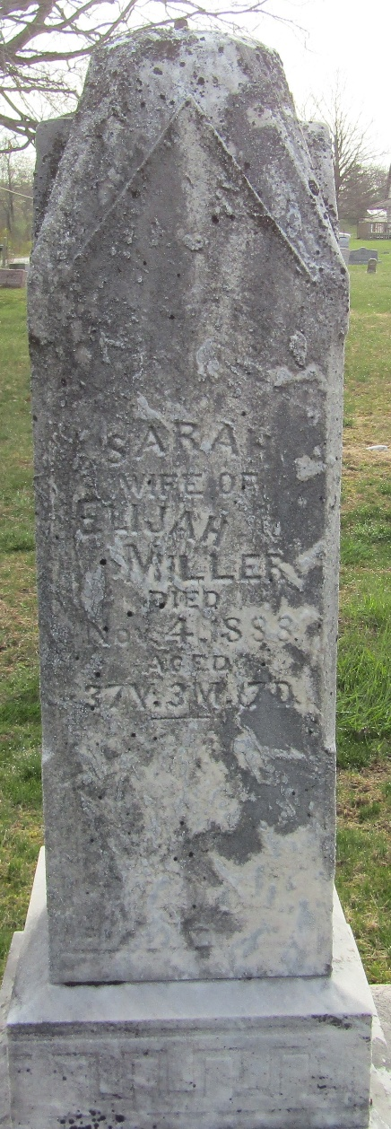

Sarah E Maddux from tree Parkison Family Tree
Birth 18 Jul 1851 Wells, Indiana, USA
Marriage 15 Nov 1871 Wells, Indiana, USA
Death 4 Nov 1888 Bluffton, Wells, Indiana, USA
Father Jacob Maddux (1818-1884)
Mother Mary Anna Evans (1820-1884)
Spouse Elijah Frederick Miller (1846-1920)

