Nancy Elwaya (Kunkle) Miller
July 28, 1832 – October 4, 1893

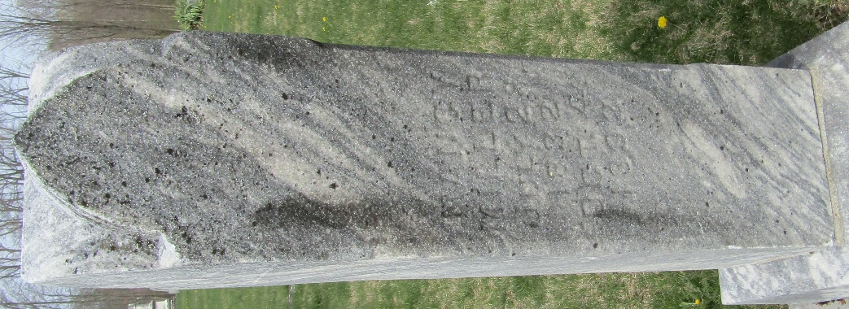

Nancy Elwaya Kunkle from tree BLEDSOE Family Tree
Birth 28 Jul 1832 Somerset, Somerset, Pennsylvania, USA
Marriage 7 Jun 1849 Crawford, Coshocton, Ohio, USA
Residence 1880 Wells, Indiana, USA
Death 4 Oct 1893 Wells, Indiana, USA
Father Michael Kunkle (1784-1846)
Mother Anna Catherine Sentz (1791-1870)
Spouse Henry Miller (1827-1876)

