Mary Ann (Sutton) Miller
1814 – January 20, 1895

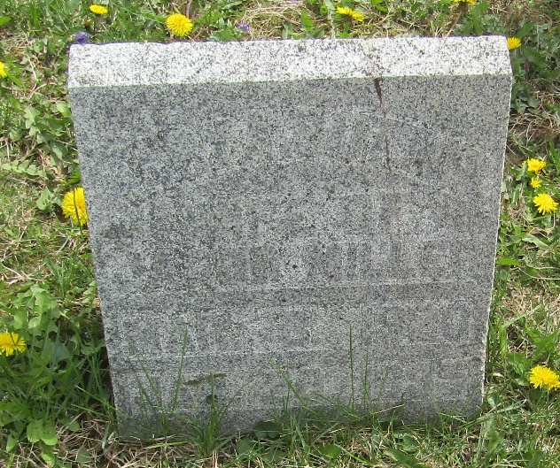

Mary Ann Sutton from tree Paules Burgan Miller Nourse
Birth 1814
Marriage 14 Oct 1841 Wells, Indiana, USA
Death 20 Jan 1895
Father Elija Sutton
Mother Diana Bowell
Spouse Jacob Miller (1814-1898)

