Lucy Miller
1850 – April 21, 1851

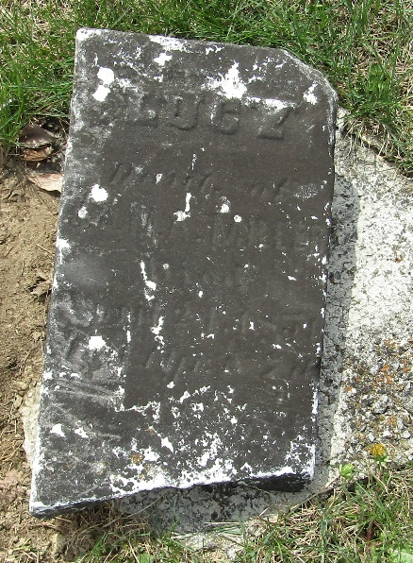

Lucy Miller from tree Mike Harris Family Tree
Birth Jun 1850 Indiana, USA
Residence 1850 Wells, Indiana, USA
Death 21 Apr 1851 Wells, Indiana, USA
Father John M Miller (Born 1825)
Mother Mary Ann Frazier (Born 1829)

