Kit Carson Miller
April 20, 1885 – June 21, 1912

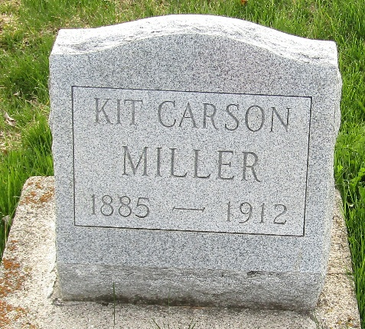

Kit Carson Miller
Indiana, U.S., Death Certificates, 1899-2017
Name Kit Carson Miller
Gender Male
Race White
Marital Status Married
Age 27
Birth Date 20 Apr 1885
Birth Place Wells County, Indiana
Death Date 21 Jun 1912
Death Place Bluffton, Wells, Indiana, USA
Death Registration Date 1912
Father David E. Miller
Mother Rosetta Fox
Spouse Ethel Cecil Grove
Informant Family; Bluffton, Indiana
Burial June 23, 1912; Murray Cemetery

