Jacob Miller
February 8, 1814 – April 8, 1896

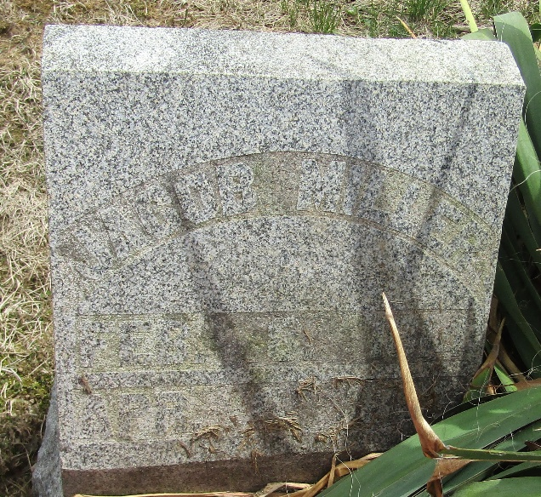

Jacob Miller
Indiana, U.S., WPA Death Index, 1882-1920
Name Jacob Miller
Date Apr 10, 1896
Location Wells County
Age 82 Yr
Gender Male
Race White
Source location County Health Office, Bluffton
Source notes The source of this record is the book H-14 on page 122 within the series produced by the Indiana Works Progress Administration.
**
Jacob Miller from tree Hays/Powlus Family Tree
Birth 8 Feb 1814 York, Pennsylvania, USA
Marriage 14 Oct 1841 Wells, Indiana, USA
Residence 1880 Wells, Indiana, USA
Death 8 Apr 1896 Wells, Indiana, USA
Father Frederick K Miller (1784-1852)
Mother Susannah Elizabeth Paules (1787-1851)
Spouse Mary Ann Sutton (1822-1906)

