Henry Miller
March 2, 1802 – June 25, 1882

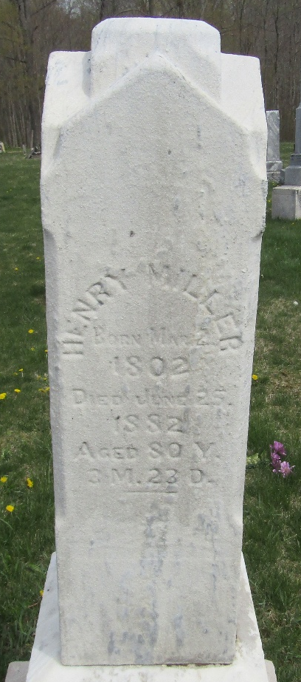

Henry Miller from tree Douglas E. Hart - Working Tree
Birth 2 Mar 1802 Carter, Tennessee, USA
Marriage 15 Apr 1824 Union, Indiana, USA
Residence 1880 Wells, Indiana, USA
Death 25 Jun 1882 Wells, Indiana, USA
Father Daniel Miller (1779-1843)
Mother Elizabeth Petrie/Petry (1772-1857)
Spouse Catherine "Caty" Seek (1801-1877)

