Henry Miller
March 10, 1827 – December 6, 1878

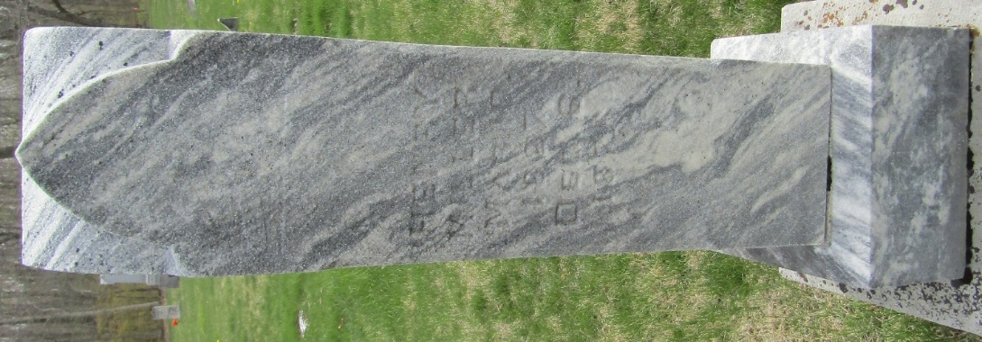

Henry Miller from tree Moore Family Tree
Birth 10 Mar 1827 Ohio, USA
Marriage 7 Jun 1849 Crawford, Coshocton, Ohio, USA
Residence 1870 Wells, Indiana, USA
Death 6 Dec 1878 Wells, Indiana, USA
Father Daniel Miller (1799-1871)
Mother Lydia Hershner (1800-1866)
Spouse Nancy Kunkel (1832-1893)

