David Eli Miller
October 25, 1861 – April 25, 1935

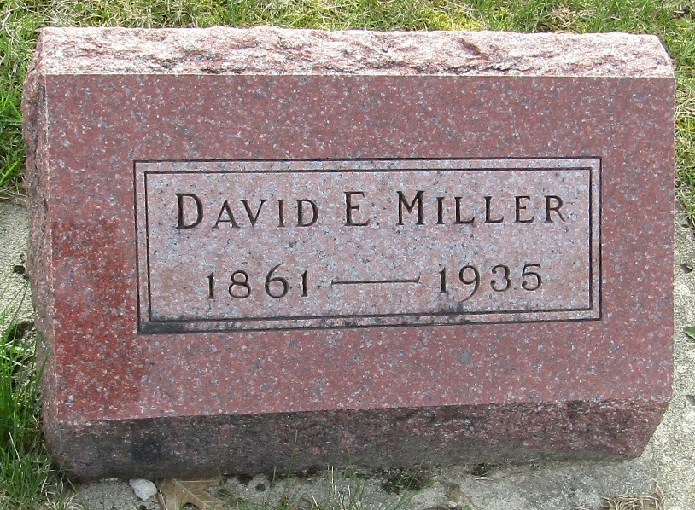

David Eli Miller
Indiana, U.S., Death Certificates, 1899-2017
Name David Eli Miller
Gender Male
Race White
Marital Status Widowed
Age 73
Birth Date 25 Oct 1861
Birth Place Indiana
Death Date 25 Apr 1935
Death Place Bluffton, Wells, Indiana, USA
Death Registration Date 1935
Father Simon Miller
Mother Mary J Alvers
Spouse Rosetta Fox
Informant Hugh Miller; Bluffton, Indiana
Burial April 27, 1935; Murray Cemetery

