Catharine (Zeek) Miller
June 10, 1801 – August 1, 1877

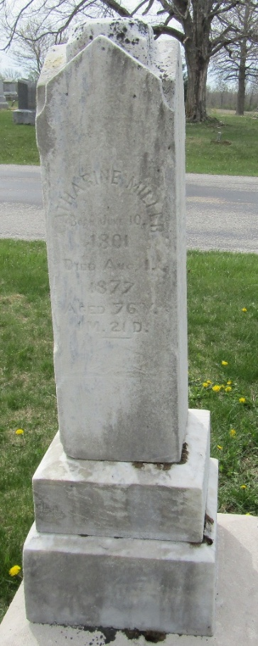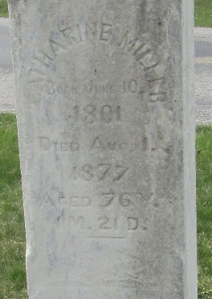

Mrs. Catherine Miller, the first white woman who settled in Wells County, was born Wythe County, Virginia, June 10, 1801. November 10, 1832, she and her husband, Henry Miller, settled on the farm where they lived until her death. From the time of her arrival here until the 4th of June following, she saw but one white woman.
Mr. and Mrs. Miller lived fifty-four years without a death occurring in their house; then August 1, 1877, she died.
At that time all her ten children were living except the youngest son, who died in Andersonville prison.
History of Wells County, Indiana
**
.... (first page missing)...Dr. Knox and Robert Harvey. Here he [Henry Miller] purchased the land on which he lived almost fifty years. He was united in marriage in Union County, Indiana, April 15, 1823, to Catherine Seek, who was born in Tennessee June 10, 1801 and died August 1, 1877. To them were born ten children - John, a resident of Kansas; Mrs. Melinda Frybuck of Michigan; Mrs. Matilda Matthews of Bluffton; Daniel, living in Illinois; Simon of Wells County, Indiana; Mrs. Elizabeth Harvey, living at Murray; Henry and Adam, living in Kansas; William, deceased; Mrs. Catherine Weaver of Lancaster Township. Four of the sons, Adam, William, Simon and Daniel, served as soldiers during the War of the Rebellion, and William died in Andersonville prison.
Biographical and Historical Record of Adams and Wells Counties, Indiana; Lewis Publishing Co., Chicago, IL, 1887
**
Catherine "Caty" Seek from tree Douglas E. Hart - Working Tree
Birth 10 Jun 1801 Wythe, Virginia, USA
Marriage 15 Apr 1824 Union, Indiana, USA
Residence 1870 Wells, Indiana, USA
Death 1 Aug 1877 Bluffton, Wells, Indiana, USA
Father Johann Adam Zick/Zeek (1773-1847)
Mother 7 -Mary "Polly" Shaffer (1785-1842)
Spouse Henry Miller (1802-1882)

