Bobbie Gene Miller
August 30, 1931 – October 8, 1931

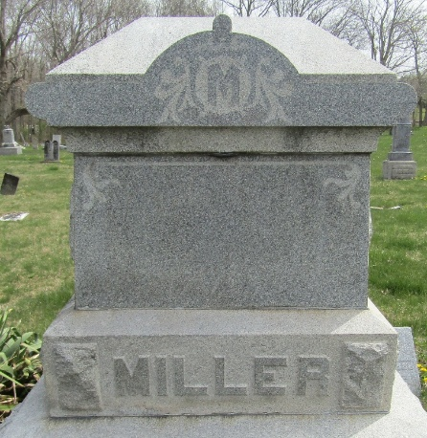

MILLER INFANT TAKEN BY DEATH
Little son of Mr. and Mrs. Hugh Miller Dies At Hospital

Bobbie Gene Miller, infant son of Mr. and Mrs. Hugh Miller, 513 South Oak street, died at 6 o’clock Thursday evening at the Wells county hospital. The child was born in Bluffton on Aug. 30, 1931, a son of Hugh and Leona Brown Miller and was one month and nine days of age at the time of his death. Surviving besides the parents are two brother (sic), Doyle and Marion, at home.
Funeral services will be held at 1:30 Saturday afternoon at the E. R. Miller home, West Market street, in charge of Rev. T. J. Bean. Burial will be made in the Murray cemetery.

Unknown newspaper clipping

**
Indiana, U.S., Death Certificates, 1899-2017
Name Bobbie Gene Miller
Gender Male
Race White
Marital Status Single
Age 1 month, 9 days
Birth Date 30 Aug 1931
Birth Place Bluffton, Indiana
Death Date 8 Oct 1931
Death Place Bluffton, Wells, Indiana, USA
Death Registration Date 1931
Father Hugh Miller
Mother Leona Brown
Informant Hugh Miller
Burial October 10, 1931; Murray Cemetery

