Benjamin F. Miller
August 8, 1842 – December 17, 1903

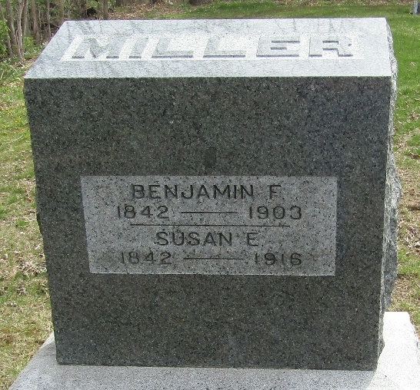

Death of Benj. Miller

Benjamin Miller, aged about 65, died at eleven o’clock this morning at his home at Murray. He had been in poor health for about a year, and a few months ago was injured by falling into the cellar at Wade Bros Restaurant. Cancer of the bone was the direct cause of death.
A wife and two children, Clyde and Miss Myrtle, survive him. There are also several brothers and sisters as follows: C. M. and J. M. Miller, Mrs. James Park, Mrs. Jonathan Brown, Mrs. James Cochran and Misses Kate and Lettie Miller of this city, and E. F. Miller of Arcanum, Ohio.
Funeral arrangements will be made on Friday.

Evening News, Wells County, Indiana,
December 17, 1903

**
Indiana, U.S., Death Certificates, 1899-2017
Name Benjamine F Miller
Marital Status Married
Age 61
Birth Date 8 Aug 1842
Birth Place Wells County, Indiana
Death Date 17 Dec 1903
Death Place Murray, Wells, Indiana, USA
Death Registration Date 1903
Father Jacob Miller
Mother Mary A Sutton
Spouse Susan
Informant Chas. M. Miller; Bluffton, Indiana
Burial December 19, 1903; Murray Cemetery

