Amanda E. (Hey) Miller
October 22, 1857 – May 29, 1927

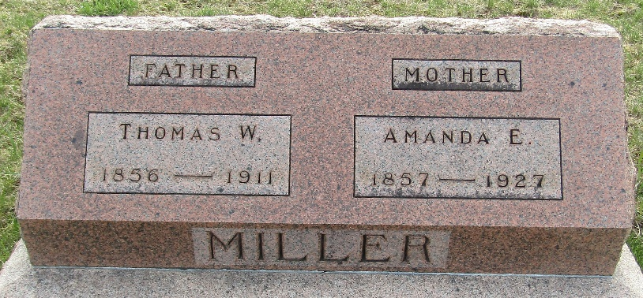

Amanda Miller
Indiana, U.S., Death Certificates, 1899-2017
Name Amanda Miller
[Amanda Hey]
Maiden Name Macklin
Gender Female
Race White
Marital Status Divorced
Age 69
Birth Date 22 Oct 1857
Birth Place Indiana
Death Date 29 May 1927
Death Place Wayne, Wayne, Indiana, USA
Death Registration Date 1926-1927
Father Joel Hey
Mother Rebecca Bender
Spouse Thomas Miller
Informant Richmond State Hospital records
Burial June 2, 1927; Murray Cemetery

