Alpha Miller
1891 – 1891

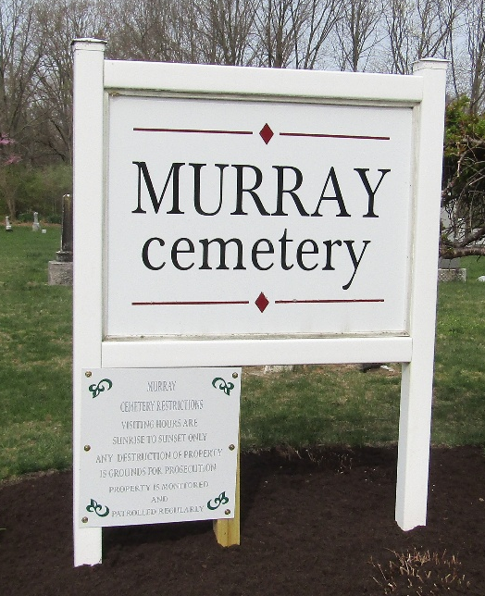

Alpha Miller from tree Fogle Family Tree
Birth 1891 Wells, Indiana, USA
Death 1891 Wells, Indiana, USA
Father Samuel Ellsworth Miller (1862-1906)
Mother Dora Belle Grames (1870-1951)

