Infant Milholland
July 31, 1902 – August 31, 1902

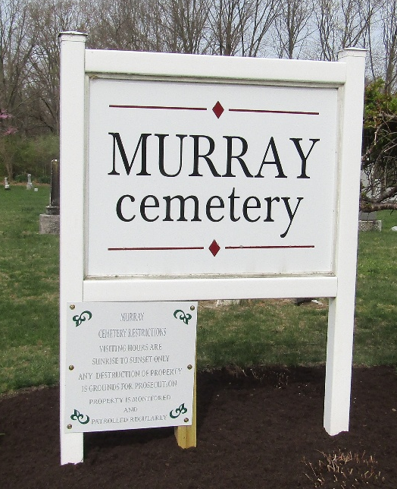

Infant Milholland
Indiana, U.S., Death Certificates, 1899-2017
Name Infant Milholland
Gender Male
Race White
Age
Birth Date 31 Jul 1902
Birth Place Warren, Indiana
Death Date 31 Aug 1902
Death Place Warren, Huntington, Indiana, USA
Death Registration Date 1902
Father W A Milholland
Mother Silvia Kleinknight
Informant W. A. Milholland; Warren, Indiana
Burial Bluffton, Indiana

