William Henry Metts
1828 - 1856

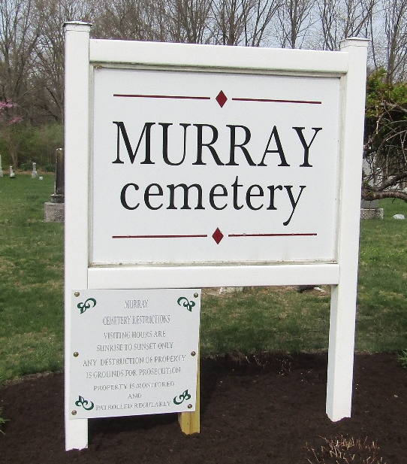

William Henry Metts from tree SecorBrunk Family Tree
Birth 1828 Licking, Ohio, USA
Residence 1850 Wells, Indiana, USA
Marriage 3 Oct 1855 Marion, Grant, Indiana, USA
Death 1856 Dublin, Wayne, Indiana, USA
Father James William Metts (1806-1874)
Mother Miranda Sutton (1813-1868)
Spouse Meriam Caylor

